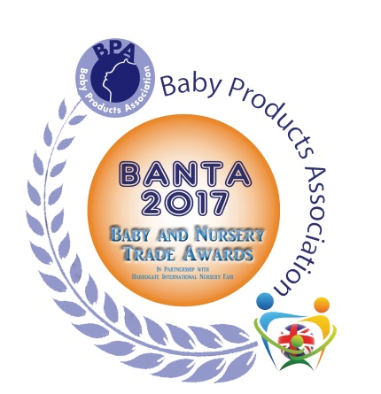

BANTA 2017
BPA Baby and Nursery Trade Awards
Entry Form

Organisation/Company Name:

Stand Number:

Product Name:

Product Description (30 words):

Category (please tick):

Travel Travel Accessories Sleep Accessories Toys

In Home Safety Feeding, Cleaning & Changing Best New Product

Why do you consider your product to be a winner? Please take into account: USP, value, quality, appeal to the consumer, special safety features (80 words):

Proposed Recommended Retail Price:

Company Contact Details (Name, Address, Telephone Number and Email):

Image Submitted: Payment Submitted:

Yes No Yes No

Signed: Date:

PLEASE ENSURE YOU READ THE RULES ON PAGE 2 BEFORE SUBMITTING YOUR ENTRY
BANTA 2017 BPA Baby and Nursery Trade Awards
Entry Form - page 2

Rules:

- Only one Product Category can be entered per item with the exception of ‘Best New Product’ which can be entered together with ONE other category.
- Entries must be received by 7th March 2017. Late entries will not be accepted.
- There is a charge of £80.00 + VAT per entry. Payment must be made within 7 days of submission of our invoice. If payment if not received, your entry will not be accepted.
- Products will be judged prior to the show and you will be notified in advance if your product has been shortlisted.
- The product must be available for final judging at Harrogate International Nursery Fair 2017.
- If your product is shortlisted, please ensure that it is adequately labeled and delivered to the Organiser’s Office at the front of Hall A by 6pm on the final day of build-up. Products will be secured overnight and an announcement will be made asking entrants to collect their products once the judging is complete. You must notify the BPA in advance if this is not going to be possible.
- Exhibitors can enter more than one product.
- Only exhibitors at Harrogate International Nursery Fair 2017 can enter.
- Winners will be announced at the Drinks Reception on 28th March 2017.
- The judges’ decision will be final.

Notes of Guidance:

Product Categories

The following information is to assist you with choosing the correct category for your product but is for example only and is not exhaustive.

Only one category per product can be entered with the exception of ‘Best New Product’ which can be entered together with ONE other category. Please note that if you enter your product in two categories (i.e. ‘Sleep Accessories’ and ‘Best New Product’), you will be charged for two entries.

Travel – All groups of car seats, wheeled conveyances and travel systems.
Travel Accessories – Travel cots, infant carriers/slings, parasols and canopies, rain covers and sleepshades, car seat accessories and pushchair accessories.
Toys – Pre-school toys, pram toys, bath toys, swimming aids and products associated with playtime activities.
Sleep Accessories – Sleep sacs, cot bumpers, bedding, mattresses, mobiles and nightlights.
In Home – High chairs, cots, Moses baskets, changing units, baby bouncers and nursery furniture.
Safety - Bath thermometers, monitors, stair gates, bed rails, cooker guards, tap guards, harnesses and reins.
Feeding, Cleaning and Changing – Nappies, changing mats, changing bags, baby baths, bubble bath and creams and mealtime accessories such as bottles, bowls, cutlery and soothers.
Best New Product – any new product which has launched to market after Harrogate International Nursery Fair 2016 and has not been seen at the show before.
Images – should be emailed or sent on disc with this application form. Images are required to be at least 10cm high and 300 dpi resolution. All entries require an image – those without will be disqualified.

Prototypes – at the time of final judging, all entries should be available for sale. Prototypes will not be acceptable for final judging.

THE JUDGES’ DECISION IS FINAL. NO CORRESPONDENCE WILL BE ENTERED INTO AFTER THE BANTA ENTRY CLOSING DATE.
Please send completed application forms to:
Julie James, Baby Products Association, Grove House, 33 Ashgrove, Steeple Claydon, Bucks MK18 2LW
Email: julie@b-p-a.org

